Activity 22.4

Jason Lorenz

1. 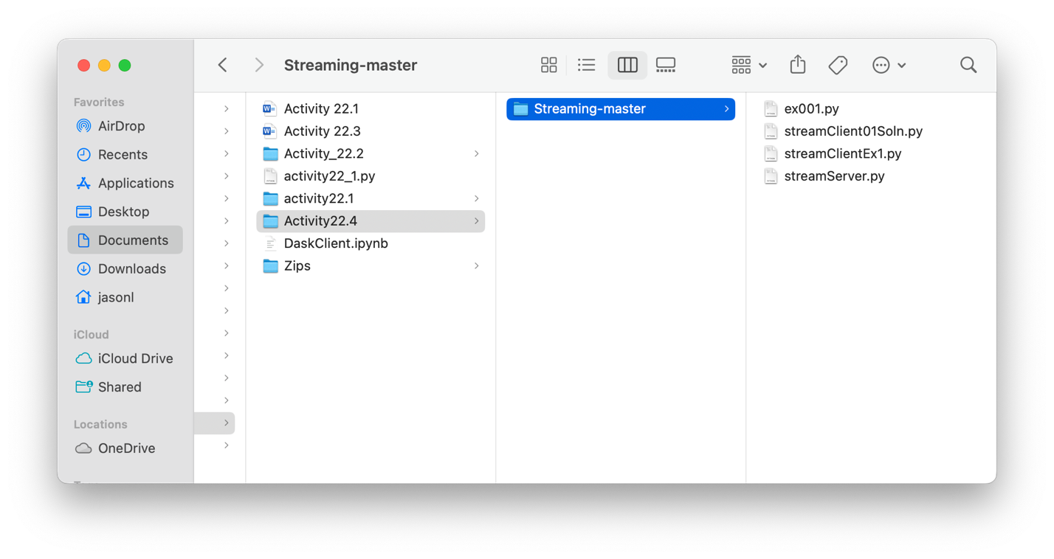
2. A screen shot of a computer

   Description automatically generated with medium confidence
3. A screenshot of a computer program

   Description automatically generated with medium confidence
4. A screenshot of a computer program

   Description automatically generated with medium confidence
5. A screenshot of a computer program

   Description automatically generated with medium confidence
6. A screen shot of a computer

   Description automatically generated with medium confidence
7. A screen shot of a computer

   Description automatically generated with medium confidence
8. A screen shot of a computer

   Description automatically generated with medium confidence